Register Now

[www.literacyindia.org](http://www.literacyindia.org)

* 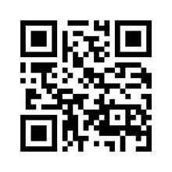

Contact no. 8588853380

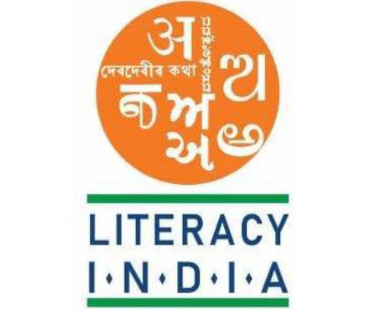

Programs Offered

Robotics/Thinkering

Mobile Repairing

Cooking/Hospitality

Beauty/Wellness

Stitching & Cutting

Electrical Troubleshooting

Two-Wheeler Repairing

Mobile journalism

Computer Science

Call Center/BPO

Logistics

Data Digitization

Natural Farming Market Connect

Banking

Literacy India Community College (LICC)